Synopsis

Project Title-
Employee Salary Prediction Using Regression Based Machine Learning

Problem Id: 03

Student Name-Ansh Gupta (Leader)
University Roll number-2028391
Section-L

Student Name-Agamya Saini
University Roll number-2028385
Section-L

Student Name-Amritaanshu Dheeman
University Roll number-2028390
Section-L

- Problem Description:

In today’s organizations, deciding an employee’s salary is not a simple task, as it depends on many important factors such as experience, education level, job role, performance, skills, and even organizational conditions.
In most cases, salary decisions are made manually by managers or HR departments, which can sometimes lead to inconsistency, bias, or lack of transparency. This makes it difficult to ensure fair and accurate salary distribution among employees. Therefore, there is a need for a system that can predict salaries in a more reliable, consistent, and data-driven manner.
In this project, we aim to build a machine learning model that can predict employee salary based on multiple input features. Since real company data is not easily accessible due to privacy and confidentiality issues, we have created a synthetic dataset consisting of 20 features that simulate a realistic working environment.
These features include both numerical and categorical variables that influence salary in real-world scenarios.
The project also involves performing exploratory data analysis to understand patterns and relationships within the data.
Data preprocessing techniques such as cleaning, encoding, and normalization are applied to prepare the dataset for model training. Feature selection is used to identify the most important factors affecting salary prediction. Multiple regression models are implemented and compared to determine the best-performing model.
Overall, this project helps in understanding how different factors influence employee salary and provides a more efficient and unbiased approach for decision-making in organizations.

- Steps of Implementation:
The project follows a structured machine learning pipeline consisting of the following phases:

- Data Collection / Generation-
Since real-world employee data is not publicly available, a synthetic dataset is generated using Python. It includes 20 features representing employee attributes such as experience, performance, and job role. The data is created in a way that maintains realistic relationships between features and salary.

- Exploratory Data Analysis (EDA)-
EDA is performed to understand the underlying structure and patterns of the dataset. Statistical summaries and visualization techniques such as histograms, scatter plots, and heatmaps are used. This helps in identifying trends, correlations, and important variables affecting salary.

- Data Preprocessing-
Data preprocessing is carried out to prepare the dataset for model training. Categorical variables are converted into numerical form using encoding methods, and numerical features are scaled for uniformity. This step ensures data consistency and improves the performance of machine learning models.

- Feature Selection-
Feature selection is applied to identify the most significant features influencing salary prediction. The forward selection method is used, where features are added sequentially based on their contribution to model performance. This reduces dimensionality and enhances model efficiency.

- Model Development-
Regression models such as Linear Regression, Ridge Regression, and Lasso Regression are implemented. These models learn the relationship between input features and salary. Regularization techniques are used to prevent overfitting and improve generalization.

- Model Evaluation-
The performance of the models is evaluated using metrics such as R² score, RMSE, and MAE. R² measures how well the model explains variance, while RMSE and MAE measure prediction errors. These metrics help in selecting the most accurate and reliable model.

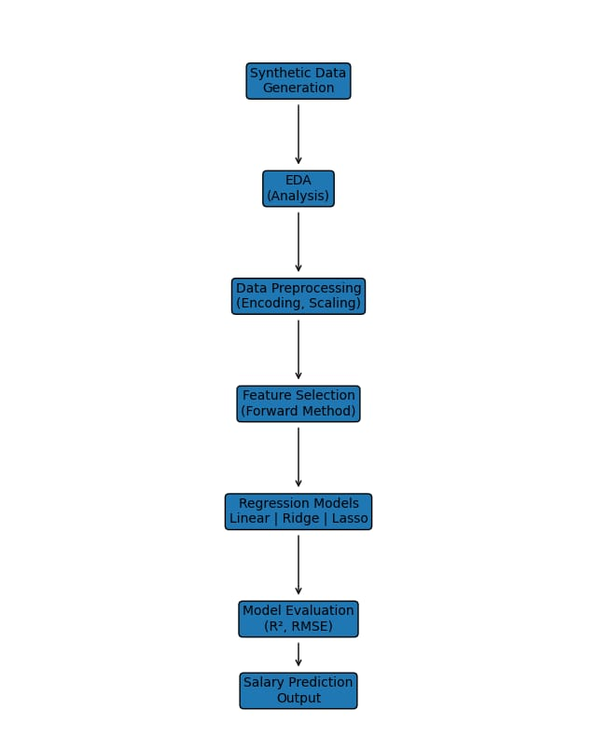

Fig. 1 Architecture Diagram

- Expected Modules/ Libraries to be used :

- NumPy-
NumPy is a fundamental library used for numerical computations in Python. It provides efficient array structures and mathematical functions required for data generation and manipulation. It is widely used for handling large datasets and performing complex calculations.

- Pandas-
Pandas is used for data manipulation and analysis through its DataFrame structure. It helps in organizing, filtering, and processing structured data efficiently. It also provides functions for reading and writing datasets in formats like CSV.

- Matplotlib-
Matplotlib is a visualization library used for creating basic plots such as histograms, line graphs, and scatter plots. It helps in understanding data trends and patterns visually. It is essential for representing analysis results graphically.

- Seaborn-
Seaborn is built on top of Matplotlib and is used for advanced statistical visualizations. It provides better-designed plots such as heatmaps and pair plots. It helps in identifying relationships and correlations between variables.

- Scikit-learn-
Scikit-learn is a machine learning library used for implementing algorithms and models. It provides tools for preprocessing, feature selection, model training, and evaluation. It simplifies the development of machine learning pipelines.

- Expected Evaluation metrics and Plots to be used:

To evaluate the performance of the regression models, multiple metrics and visualization techniques are used to ensure accurate and reliable results.

- R² Score-
R² score measures how well the regression model explains the variability of the dependent variable (salary). It indicates the proportion of variance captured by the model. A higher value represents better model performance.

- RMSE (Root Mean Squared Error)-
RMSE measures the average magnitude of prediction errors by taking the square root of squared differences. It gives more importance to larger errors, making it useful for detecting significant deviations. Lower RMSE indicates better accuracy.

- MAE (Mean Absolute Error)-
MAE calculates the average absolute difference between predicted and actual values. It provides a simple and interpretable measure of error. It is less sensitive to outliers compared to RMSE.

Visualization Plots-

- Histogram-
Used to analyze the distribution of numerical features such as salary and experience. It helps in understanding the spread and frequency of data values.

- Scatter Plot-
Used to study the relationship between two variables, such as experience and salary. It helps in identifying trends, patterns, and possible correlations.

- Heatmap-
Used to visualize the correlation between different features in the dataset. It helps in identifying strongly related variables that influence salary prediction.

- Required topics from the subject:

- Strings-
Strings are used to handle categorical data such as job role, department, and education level. They help in storing and processing textual information in the dataset. String operations are also useful during data cleaning and transformation of categorical values into numerical form.

- Files-
File handling is used to read and write datasets in formats like CSV. It allows efficient storage, retrieval, and sharing of data. This is important for loading datasets into the program and saving processed data or results.

- Functions-
Functions are used to organize the program into smaller and reusable blocks of code. They improve code readability, maintainability, and reduce repetition. Functions also help in structuring different stages of the machine learning pipeline.

- Libraries-
Libraries provide pre-built tools and functions for data analysis and machine learning. They simplify complex tasks such as preprocessing, visualization, and model building. Using libraries improves efficiency and reduces development time.

- Platform Required:

- Jupyter Notebook-
Jupyter Notebook is used for writing, executing, and testing code in an interactive environment. It allows combining code, outputs, and visualizations in one place. This makes it ideal for data analysis and experimentation.

- Python (IDLE / VS Code)-
Python is the main programming language used for implementing the project. IDEs like IDLE and VS Code provide an environment for writing, debugging, and running code efficiently. They support various libraries required for machine learning.

- GitHub-
GitHub is used for version control and managing the project repository. It allows multiple team members to collaborate and track changes in the code. It also helps in organizing the project into phases and sharing it with others.

- Books and Link Sources:

- Python for Data Analysis – Wes McKinney

- Hands-On Machine Learning with Scikit-Learn, Keras, and TensorFlow – Aurélien Géron

- https://scikit-learn.org⁠ - for official documentation of machine learning models and preprocessing.

- https://www.kaggle.com⁠ - for dataset and practice.

- https://pandas.pydata.org⁠ - for official documentation of data analysis and manipulation.

